**Project Hub Bug Details (30-10-24):**

1. Kanban Board- Task type displayed empty value. -Fixed-Fail(Need to add any oe ne option from the dropdown and it should not in empty status)Not fixed
2. Kanban Board- After select Task type from dropdown, it should automatically closed. Fixed-Pass
3. Kanban Board- Extra arrow button present near Task Type. Fixed-Pass
4. Kanban Board-When click the kanban board in task management , details displayed empty values. Fixed-Pass
5. Kanban Board- When add task “In Progress” and other tabs details is continuously saved in first column “BackLog”. Fixed-FAIL(Same issue occurred)Not fixed
6. Kanban Board- Multiple task type is able to select, is that a feature or bug?-Need confirmation from project lead. Fixed-Pass
7. Kanban Board-Column name should display full details. In Select for development full text is not displayed. Fixed-FAIL(Same issue occurred)Not fixed
8. Kanban Board-First five column user cannot able to delete, so there no need for delete button for the five columns. Need to remove the delete button Fixed-Pass
9. Kanban Board- Create task and Edit task displayed different kind of pop up. Fixed-Need confirmationAfter meeting only we can change this
10. Kanban Board-Edit the task-When enter sub-task and click cancel button and again click the create task button, previous details are displayed. Fixed-Pass
11. Kanban Board-Edit the task-After save a sub-task, in that tab when click the Image icon, a unwanted pop up is displayed.-Fail(It need to show below to the user icon) Fixed-Need to discuss - Fixed-Pass

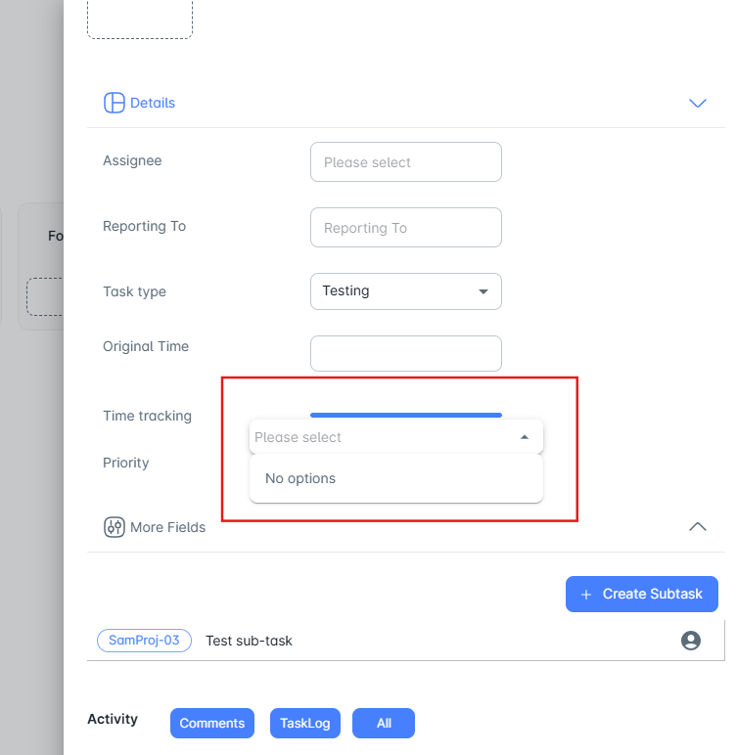

1. Kanban Board-Edit the task- After click task log button, no details is displayed and when click all button, task log detail is displayed. But when click all button both comments and task log detail should display. Fixed-Fail-fixed-Fail(Same issue occurred)
2. Kanban Board-Edit the task- In Details tab arrow button display downward only. Fixed-Pass
3. Kanban Board-Edit the task- In more fields tab arrow button display upwards only. Fixed-Fail(Arrow present in wrong direction)fixed-Pass
4. Kanban Board-Edit the task- There is no save button for after modify the task details, save button only present for description. Fixed-Pass
5. Kanban Board-Edit the task-Time Tracking-Time select option AM should present in top and PM should present in bottom. Fixed-Pass
6. Kanban Board-Edit the task-Time Tracking-Change cancel option into clear option. Close button is already present so no need for cancel button. Fixed-Pass
7. Kanban Board-Edit the task-In details tab, Intially the assignee and reporting to dropdown details are empty. Once click the task name in top of the pop up, values are displayed. Fixed-Pass
8. Release-Empty details is displayed in the grid. Fixed-PASS
9. Release-After click add new button, automatically displayeed the error message in start and end date. Fixed-PASS
10. Release-Add/edit, after click clear button, start and end time is not cleared. Fixed-PASS

**New Bugs-04-11-24:**

1. **HOMEPAGE:**
2. After login, left bottom corner display profile option and right upper corner also display profile option, need to remove any one option. May be remove the left bottom corner option.Not fixed
3. After Login, click profile button in top right corner, in that page two logout option is displayed. Not fixed
4. After Login, click profile button in top right corner, there is no need to display the project and kanbanboard option in the profile option. So, remove those two options. Not fixed
5. **KANBANBOARD & TASK:**
6. When try to edit the task and saved successfully, but the mail user name received as “Null”. Fixed-PASS

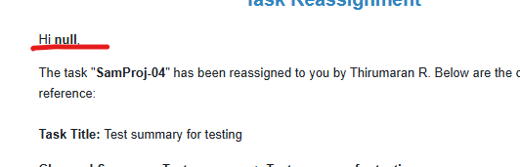

1. Task type text background doesnot match with the original background fixed-PASS
2. When edit the second and third task except first task, edit task page dispalyed from below, it should show from starting details of the pop up. fixed-FAIL(same issue occurred in In progress column) - (checking)
3. When click add column and enter valid details and click delete button, but column is not deleted. fixed-PASS
4. Click edit task, time tracking values with or without same colour is displayed. It need to show different colour when enter the time. fixed-PASS
5. Click edit task, when click clear button below to the description, summary value only cleared and description is not cleared. fixed-PASS
6. Click edit task, when click clear button, heading also gets cleared. Heading should not gets clear. fixed-PASS
7. Click edit task, Clear functionality is not properly working. fixed-PASS
8. Click edit task, need to increase the description text size. fixed-PASS
9. Create/Add task, need to fix the type of attachement file type. Currently it accepts all kind of files. fixed-PASS
10. When click create button, alignment is changed.Not fixed

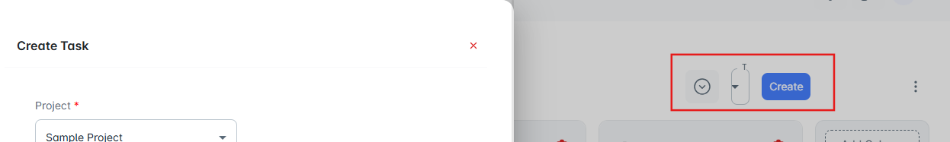

1. Click edit task, in attachments field, when try to upload a file via drag and drop first time file is not uploaded but again try to upload same or different file via drag and drop two files are imported. Fixed-FAIL(First time file upload is not working) – (checking)
2. Click edit task, need to add edit option in time tracking field after add the time spent. fixed-PASS
3. Click edit task, raised by option is empty. fixed-PASS
4. In kanbanboard homepage, search box is not working. fixed-FAIL-Not Fixed
5. Create/Edit-Description and Comments field after enter a text and select the text and click hyperlink button, option is displayed out of the textbox. Not fixed

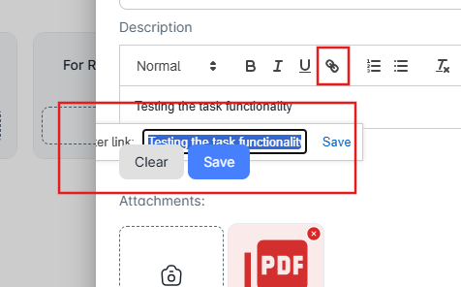

1. Click edit task, when enter valid details in sub-task, extra new task created based on the details from sub-task. (Is that a feature?) - Feature-Accepted
2. When click create task and click ESC button in keyboard, pop up should close. Fixed-PASS
3. Click edit task, In right corner project ID is look like link text need to remove the underline for the ID. Fixed-FAIL(When click the button, one task is changed to another task-Issue occurred for PROJ-02 and after click, PROJ-02 to PROJ-04) - Fixed-PASS
4. **PROJECT:**
5. When click add/ edit project, after that, click support mail setup, pop up size is change(Increased), but pop up size should be static. done-PASS
6. When click add/ edit project, after that, click support mail setup. Then click close button and again click add/ edit project pop up shows support mail setup details but it need to show Project setup details. done-PASS
7. When click add, then enter valid details in project setup details and tab moves to support mail setup details tab, here below of the pop up 2 clear option and save and update option is displayed. done-PASS
8. When click add, then enter valid details in project setup details and tab moves to support mail setup details tab, here status option is empty. done-PASS
9. When click add, then enter valid details in project setup details and support mail setup details tab and click update button details gets saved but pop up is not closed. It need to close once click save button. done-PASS
10. When click edit button, in support mail setup details tab previously entered details is not displayed. done-PASS
11. When click add, then enter valid details in project setup details click update button success message should displayed like “Project setup saved successfully” or anyother valid message. done-PASS
12. When click add, then enter valid details in project setup details and support mail setup details tab and click update button success message should displayed like “Email configuration saved successfully” or anyother valid message. done-PASS
13. In project homepage, in created on column, time details is not properly displayed. And also it need to show in the format of AM and PM. Cuurent removing from Project screen-FAIL- Fixed-FAIL
14. When click add, in project setup, After add email id and click update button details saved successfully and again click edit button of same project name Email ID field is empty. Done-PASS
15. When click add, in project setup, when click support radio button both email and add team is displayed. done-PASS
16. In project homepage, when try to search a project name, first column number is not displayed properly. done-PASS

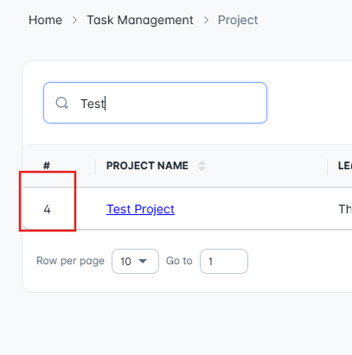

1. In project homepage, when try to sort by option, first column number is not displayed properly. done-PASS
2. Click Edit button and update valid details in Project setup page and click update button details gets saved without any issues, but in lower side of the pop up, time details are not display properly. Currently removing created and modified from this screen-NotAccepted - Fixed-FAIL

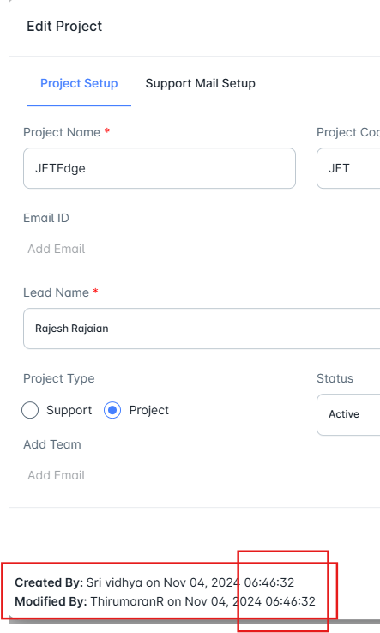

1. When project status change to inactive, the same project name is displayed in the kanbanboard project select arrow buttonNot fixed- Fixed-Fail(Project name shows 2 times)
2. In project homepage, created on column, once the project name updated, modified date and time is displayed in the column but the column should only display the date and time of project creation period. Done-FAIL
3. In project homepage, when click add new button and click ESC button in keyboard, the add new button UI is not proper. Done-PASS

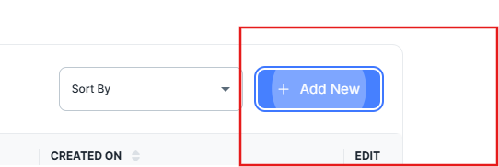

1. **RELEASE:**
2. When click release button in task management module, When click Add New button, start and end date red border is automatically displayed. Done-PASS
3. When click release button in task management module, When click Add New button, after enter valid details success message is displayed but the saved details is not displayed in the release home page. Remove Add New From the screen-Accepted
4. When Click add new button, start and end date is not able to select at first time. - done-PASS
5. When Click add new button, select the start and end time pop up need to automatically closed after select the time from the option.-Fail- Fixed-Fail
6. When Click add new button, after enter valid details and click clear button select task value is not cleared. done-PASS
7. After valid path and notes in deployement details page and click next page, page navigates to release checklist page and again click back button, previously entered details are not displayed in the deployment details page. Working- Fixed-PASS
8. In Release Checklist, after select all check box and click submit button, page displays like “Failed to save checklist” alert message.done-PASS
9. In Client mail send page, in subject field, pre-defined text is wrong. Fixed-FAIL

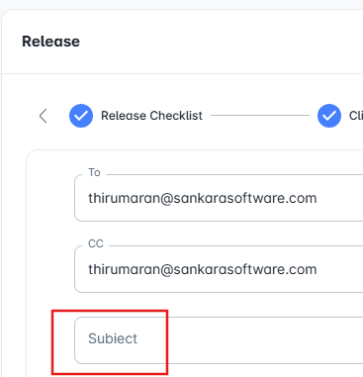

1. In Client mail send page, in subject field, User cannot able to enter any values in the field . done- done-FAIL(Need to discuss)
2. In Client mail send page, in mail body field, user cannot able to freely type the details. When enter single character, text cursor is automatically hide and user cannot able to type anything. Not fixed- Fixed-FAIL(Need to discuss)
3. Need to improve the performance of the release page, because after Release Checklist page, other tab performance is too slow and success message is also displayed after more than 5seconds Done- done-FAIL(Need to discuss)
4. In release page, when moves to deploymemnt request page, top heading display all are in tick condition, so user gets confused which page they are working. Not fixed
5. In Deployment Request, after click view log button, details are displayed as empty. Done- done-PASS
6. In Deployment Request, in mail body, need to remove the extra unwanted features. Done- done-PASS

**New Bugs(08-11-24):**

1. Dropdown symbol not match with background –Not Fixed

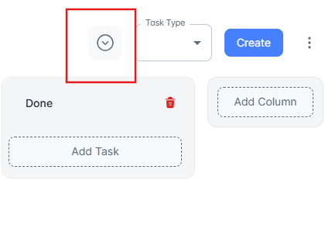

1. In edit task, in time tracking, start date and time spent mandatory symbol need to add. -Fixed-PASS
2. -In edit task, in time tracking, without enter description and click save button it’s not working, it only works after something in the description box.-Fixed-PASS
3. In Project, Add/ Edit-In support mail setup, scroll function is not properly working. -Fixed-FAIL
4. In Project, add a prject with email id and click save button and again click same project name edit button, email id field shows empty value. -Fixed-PASS
5. In Project, Edit- need to add latest modification date and time in both Project setup tab and support mail setup tab seperately. -Fixed-FAIL(both create and modify date is same value is displayed).
6. In release, add release-In start date and end date, where ever the user click within the respective tab, options should open. -Fixed-FAIL(It only open when click the calendar button)
7. In release, add release-In start time and end time , where ever the user click within the respective tab, options should open. -Fixed-FAIL(It only open when click the timer button)
8. In Release Checklist, previous release configuration tab, pre definedly radio button should select and radio button should not in empty status. -Fixed-PASS
9. In release, after click the submit button in Release Checklist, success message is displayed and page is not moves to next tab and also next button is not enabled. -Fixed-PASS.

**New Bugs-11/11/24:**

1. After user gets any kind of mail like release, project creation and all other mail, need to add the project name.
2. Need to add the project name in the login page.
3. After receive “Task Reassignment” mail, in the mail view task button is displayed but user cannot able to click.

**TIME TRACKING BUGS:**

1. In Enter Timesheet, UI of date and time is not proper, need to improve.

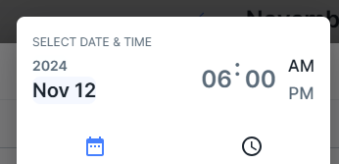

1. In Enter Timesheet, In select date and time, both date and time should be editable. – It is a theme-mode calendar, so it can't be edited. I have considered and made changes to address this issue.
2. In Enter Timesheet, In add event, after click clear button pop up is automatically closed bt it need to erase the entered values only. - Done
3. In Enter Timesheet, After add event, time sheet UI is not proper.

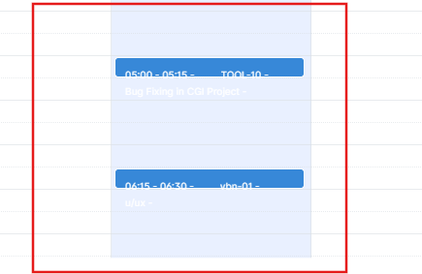

1. In Enter Timesheet, After add event, Click the event, title is non editable manner need to change to editable manner. - Open
2. In Enter Timesheet, After add event, Click the event, when click the delete button, success message is dispalyed but it wont delete. - Done
3. In Enter Timesheet, After add event, in the timesheet table, title name is too small. - Done
4. In Enter Timesheet, After adding multiple events, UI is not proper. - Let us discuss and I will tell you about this bug

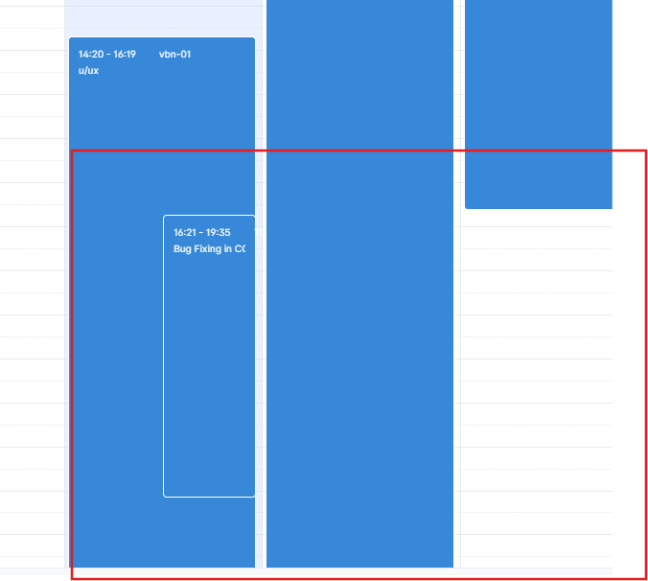

1. In View Timesheet, after click the entered time, unwanted enteries are displayed. - Done
2. In View Timesheet, after click close button, close action is not properly working. - Done
3. In View Timesheet, download button is not working. - Done

